Year 3 GP Workshops Report

2019-20





**Contents**

Introduction 3

Feedback 4

Year 3 Overall Powerpoint Slides 6

Domestic Violence Slides 6

COGconnect Slides 7

Teaching Prescribing Slides 7

# Introduction

Dear reader,

This document summaries the content of the GP3 workshops delivered in 2019.

Unusually 3 workshops were delivered (in Cirencester, Somerset and Bristol) in order to facilitate the attendance of as many GP tutors as possible.

The slides for all the sessions are available on our website (links provided) and a flavour of the feedback received is also included.

Thank you to all who attended and made them such worthwhile events

Dr Ciaran Conway & Dr Simon Thornton

Year 3 GP Leads

# Feedback

Overall feedback on the Bristol Workshop was good or excellent (figure1 and table 1) . We had two guest speakers on the day Bristol Workshop; Dr Claire Hawcroft spoke about domestic violence in MB21 (figure 2), Dr Rupert Payne about teaching prescribing (figure 3) and Prof. Trevor Thompson about the COGconnect model of consulting. Slides for all sessions are available on our website:

<http://www.bristol.ac.uk/primaryhealthcare/teaching/workshops/workshopreports/>

**Figure 1**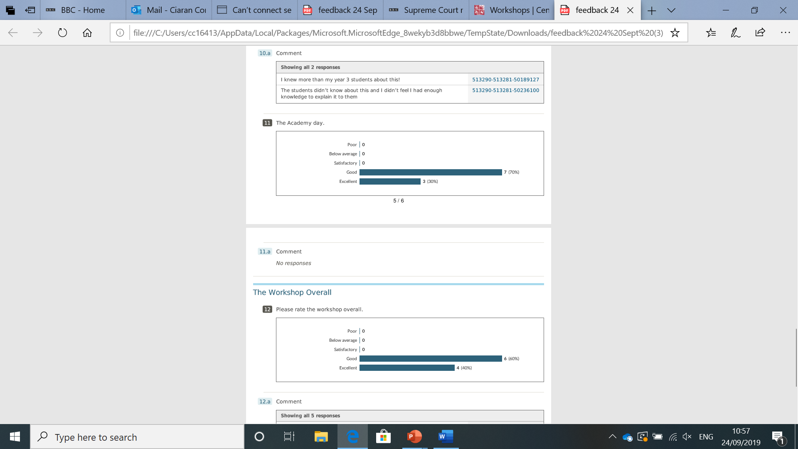

Positive

“I liked the enthusiasm from Simon and Ciaran”

“Very enjoyable and energising – well done!”

“Friendly environment -good overview of year 3”

“Very useful to have just before the students arrive. Thank you”

“Brilliant…. Thank you for all your hard work team”

Negative

“The only very minor issue was the sound” (Cirencester)

“I feel it could have been done more succinctly” (Bristol)

**Table 1 – Free text comments.**

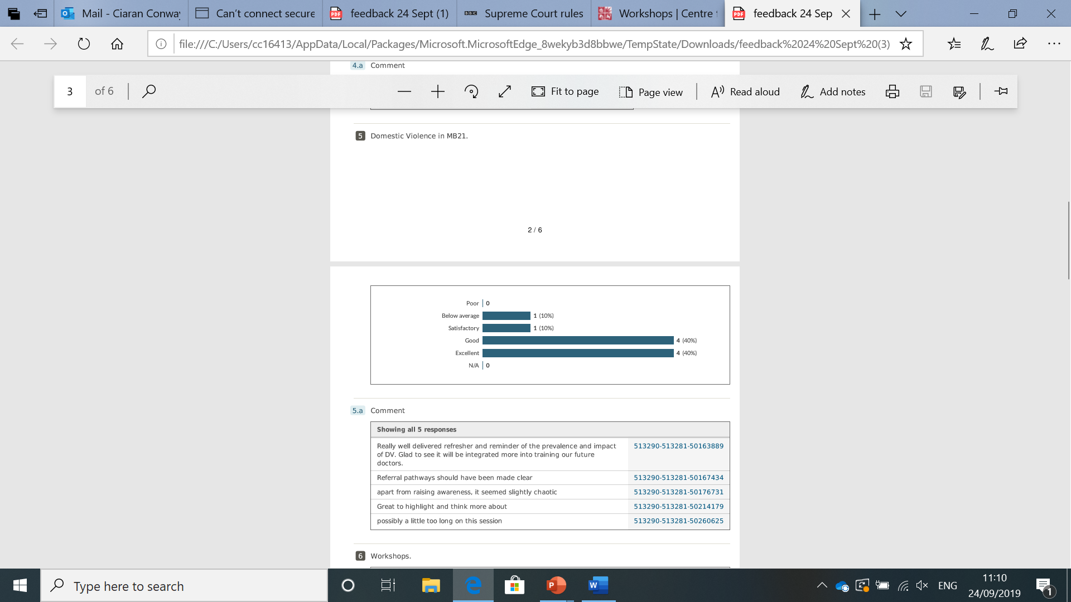

**Figure 2 – Feedback for session on domestic violence**

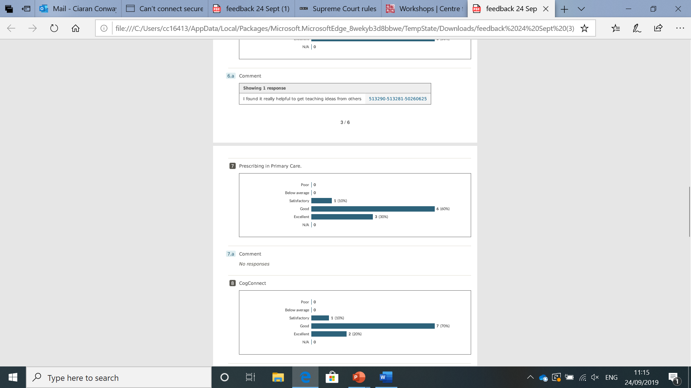

**Figure 3 – Feedback for session on prescribing in primary care**

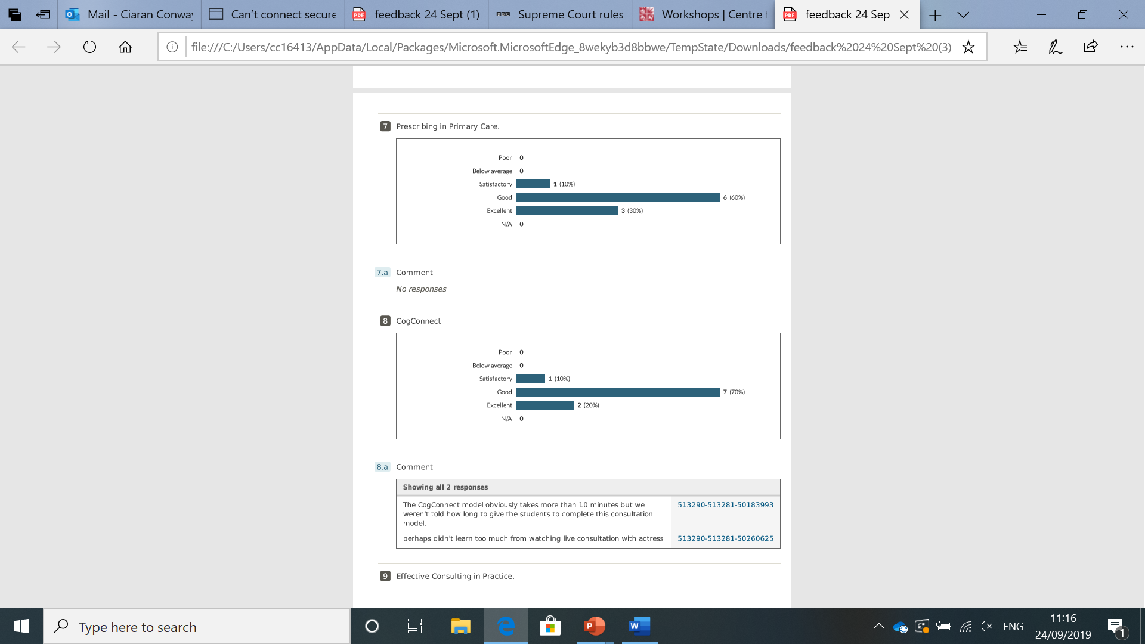

# Year 3 Overall Powerpoint Slides

These slides are available on our website: <http://www.bristol.ac.uk/primaryhealthcare/teaching/workshops/workshopreports/>

Year 3 MB21 GP Teachers Workshop slides 2019

# Domestic Violence Slides

These slides are available on our website: <http://www.bristol.ac.uk/primaryhealthcare/teaching/workshops/workshopreports/>

DVA in MB21 slides

# COGconnect Slides

These slides are available on our website: <http://www.bristol.ac.uk/primaryhealthcare/teaching/workshops/workshopreports/>

COGConnect Slides Yr3 GP workshop

# Teaching Prescribing Slides

These slides are available on our website:

<http://www.bristol.ac.uk/primaryhealthcare/teaching/workshops/workshopreports/>

Teaching prescribing to medical students Year 3 2019